**Mircroscope Drawing Name: ___________________**

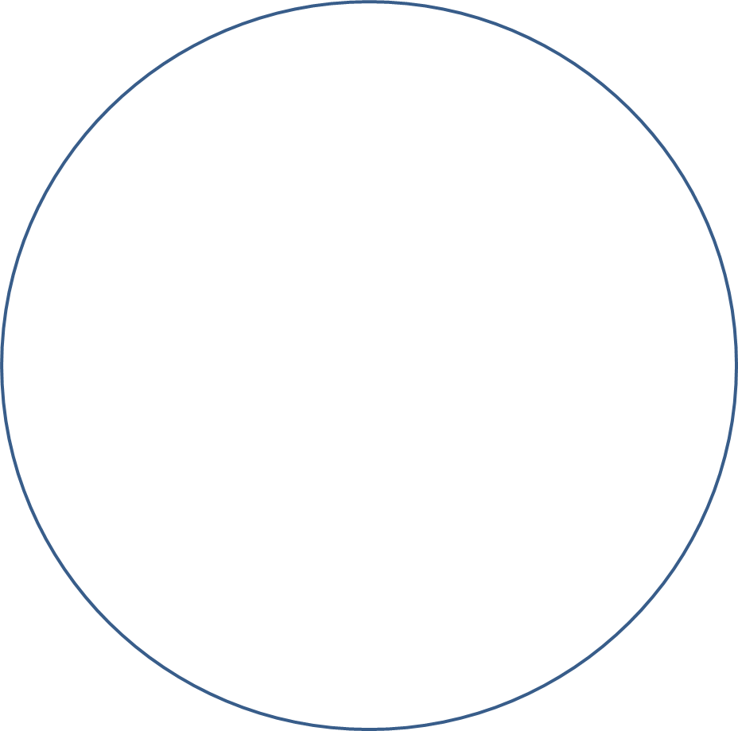

Magnification: ______